19.25: For constant 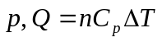
Since the gas is ideal, 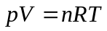 and for constant 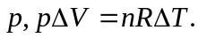
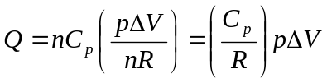
Since the gas expands, 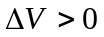 and therefore 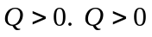 means heat goes into gas.

